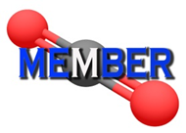

Workshop on membrane processes for CO₂ capture

- Please fill in this document and send the file to MEMBERWorkshop2019@tecnalia.com
- The workshop will be held on January 15th, 2020, in Eindhoven University of Technology
- The workshop is free of charge; travel and accommodation at own expense.
- After the registration, a confirmation e-mail will be sent in few days.
- You can contact the previous e-mail if you have any further question.

Registration:

Your information will only be used for this registration.
Please fill in the fields hereafter. All fields are required.

Title:
First Name:
Family name:
Job Title:
Organisation:
Address:
City:
Post Code:
Country:
Phone:
E-mail:
Poster Title / Authors / Organisation | Fill in “NO” if you do not present a poster

Venue:

The Conference will take place in Eindhoven University of Technology: Auditorium Building, room 4

